21/05/24

LIES, DAMN LIES and NET ZERO

Ben Pile reported in The Daily Sceptic that the Guardian recently published its survey of ‘climate experts’. For the purposes of creating this story, the Guardian’s Environment Editor Damian Carrington contacted 843 ‘lead authors’ of the Intergovernmental Panel on Climate Change’s reports (IPCC) and 383 responded to his questions. The actual substance of the survey does not seem to have been published by the paper, but the main response Carrington wanted to get from his respondents was an estimate of how much global warming there will be by the end of the century. “World’s top climate scientists expect global heating to blast past 1.5ºC target,” claims one headline. A graphic in the article shows the responses:

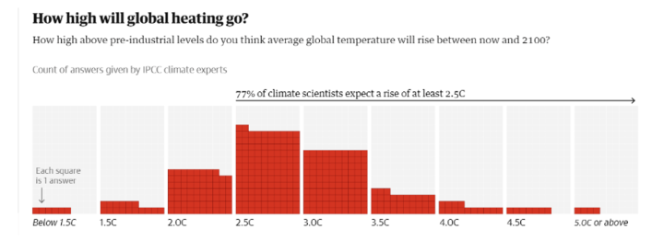
Ben Pile pointed out that the obvious problem this raises is that such a wide range of views on the next three quarters of a century discredits the notion that the IPCC represents a ‘scientific consensus’ on climate change. The ‘consensus’ – the putative expression of agreement by the worlds ‘top climate scientists’ – is the lynchpin of the narrative, epitomised by the Guardian, that the climate debate is between scientists and denialists. “Seventy seven per cent of climate scientists expect a rise of at least 2.5ºC,” explains the chart. Well, yeah, but 23% of climate scientists do not. And a good number of those connected to the IPCC believe that there will be just 1.5 degrees of warming – a third less warming than is anticipated by their colleagues at the other end of the spectrum. Clearly, there is, or needs to be, a debate.
Clearly, the wide range of results shows how utterly stupid the so-called IPCC “experts are and the organisation is itself a complete joke as it cannot even get its so-called experts to agree on a point which is fundamental to its whole existence.
However, help is at hand, because I can state the exact number that the IPCC’s own results show should be the answer!
The question was: “How much global warming will there be by the end of the century”?
Firstly, for more information on the numbers and figures involved it is necessary to refer to my note referenced below:

https://mail.google.com/mail/u/0?ui=2&ik=f96df54420&attid=0.1&permmsgid=msg-a:r-8725386989335802803&th=18f4c85a7c53cd66&view=att&disp=safe&realattid=f_lvbqnqvh0
Now we have to estimate the possible rise of CO₂ from the present day to that at the end of the century, 2100 or in 76 years time.
The total global rise in CO₂ from 1980, (335 ppm) to 2024 (420 ppm) was 85 ppm or nearly 2 ppm/annum over the last 44 years. Hence, at that rate the global total of CO₂ will rise about
152 ppm. So, the global total CO₂ level will be about 420 + 152 ppm = 572 ppm.

For convenience sake let us round this figure up to 600 ppm.

From figure 2 of my note above the ΔT (increase in temperature) against CO₂ ppm for 420 ppm is 3.5 ºC and that for 600 ppm is 4.05 ºC.

Hence the global temp increase by the end of the century implies a total temp increase of 4.05 – 3.5 ºC or just 0.55 ºC.

This is the effect of global CO₂ increase. That due to humans is 3% of the total. So, the human contribution to the total global temperature rise is about 0.017 ºC.

So, the ACTUAL ΔT due to human activity is 0.017 ºC or:

17,000 ppm of 1 ºC

The UK contribution to global CO₂ increase is about 1% of the total human contribution. So the UK’s element of the temperature increase is:

170 ppm of 1 ºC

But the Guardian article and the whole climate change hysteria evidently assumes that the increase in global temperature is entirely due to human activity. This is evident because no distinction is drawn between them. Hence, the responses from 77% of the so-called climate experts of the IPCC which claim a 2.5 ºC rise in temperature is nearly 150 times too large! Their answers range from 90 to 300 times too large. So ALL of the so-called IPCC experts who responded got nowhere near the ACTUAL temperature increase that the IPCC results predict!

It is therefore clear that the IPCC’s predictions of catastrophic climate change are nothing more than total horse manure, which is spread around by the shovel full by the media. Unfortunately, this is swallowed wholesale by our politicians, such as Sunak and Corthino, and the climate fanatics to the total detriment of our society and economy.

As the IPCC is so unreliable I have argued in my note above that their results should be ignored in favour of data produced by the eminent scientists Dr William Happer, of Princeton University and Dr van Wijngaarden, of York University, Canada, (see FIG 1 of my note). The revised and probably much more accurate result is that the temperature increase due to the human element of increasing the global CO₂ level from 420 ppm to 600 ppm is:

0.0036 ⁰C or 3,600 ppm of 1⁰C

of which the UK contribution would be:

36 ppm of 1⁰C

CONCLUSION
It is absolutely scandalous that the government is basing its policy on such a ridiculous entity as the IPCC. This was set up purely and primarily to promote the concept that human activity causes increased levels of CO₂ which is causing catastrophic global temperature increases.

The hysteria generated by the IPCC and the media, including the BBC, Sky News and the Guardian for example suggests that the title of this note should be changed to:

FOOLS, DAMN FOOLS and GOOD GRIEF, HOW STUPID CAN YOU GET?

J Wraith

